1. Create Chart between Measure Names and Measure Values. Add filter to Measure Names:

1. Create a chart for the total profit on different years along with the profit earned by months:

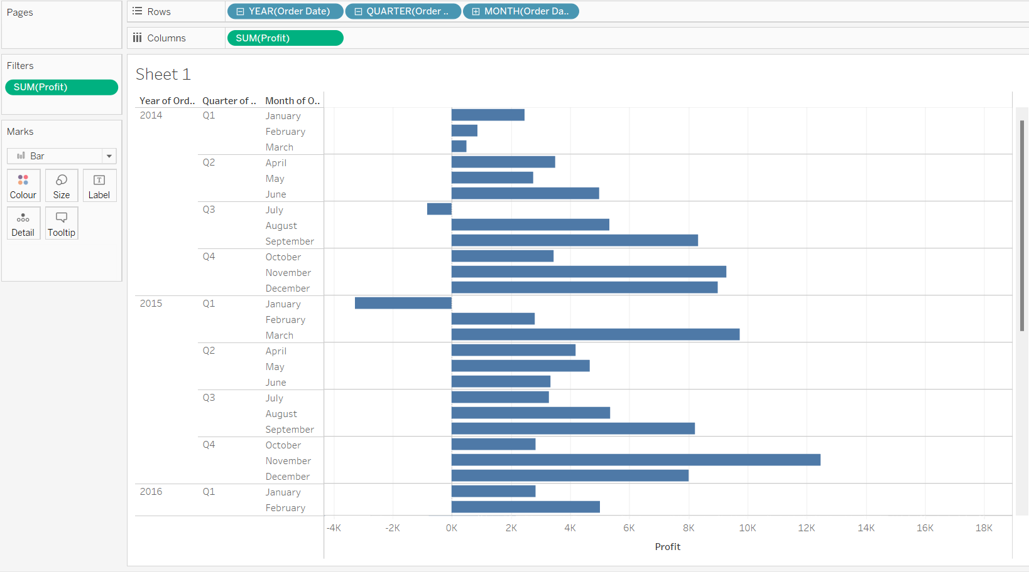

1. Create chart for the total profit on different years along with the profit earned by months on the x-axis:

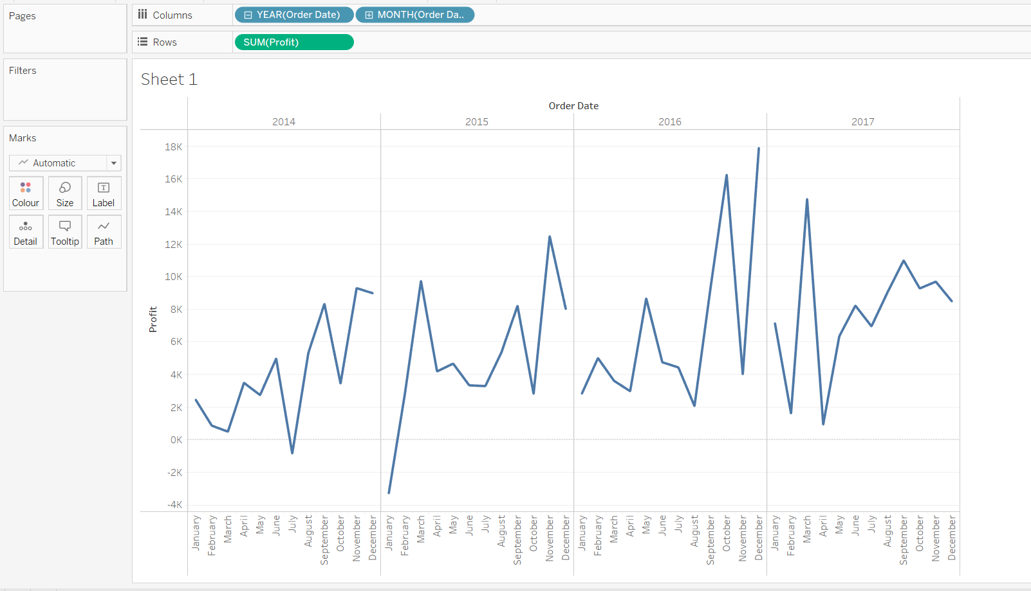

1. Create a text table for the Avg (Sales) for each subcategory using Sample Superstore?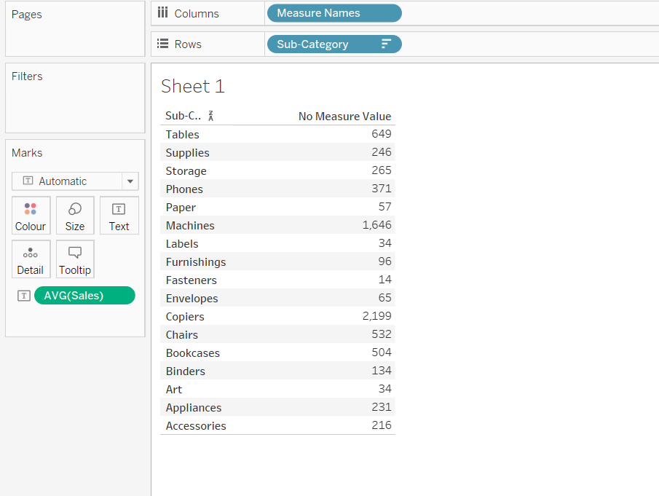
2. List which Subcategory is got Avg (Sale) more than $1000? -Sample Superstore:

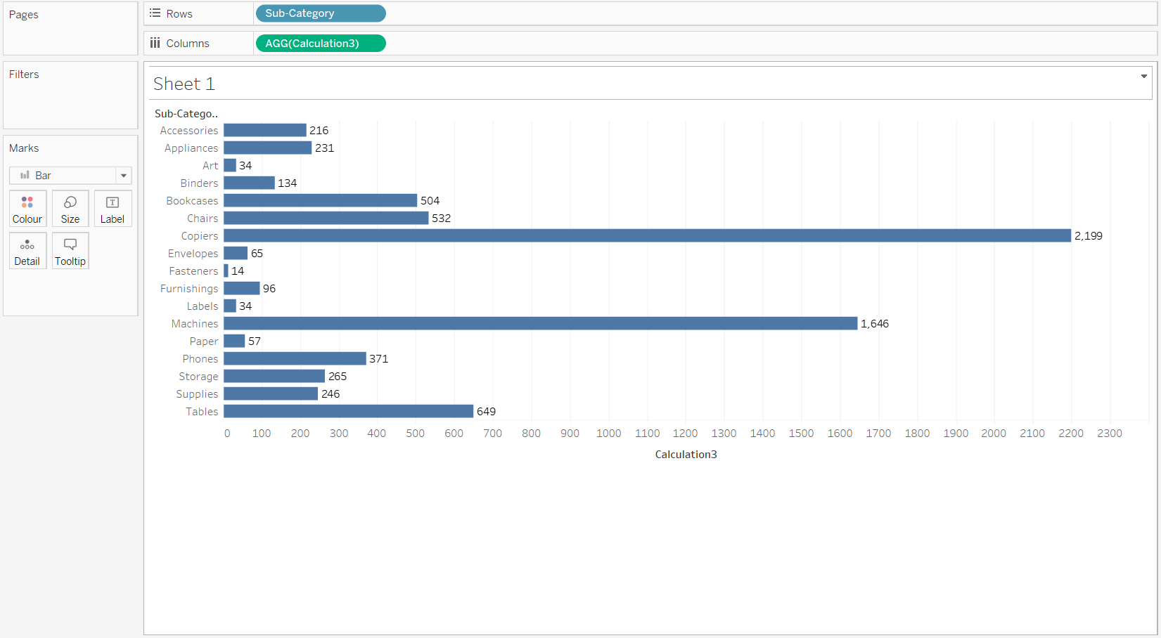

1. Create a Highlight table for the States for the Order Date Year whose highlighting is done based on Sum of profits -Sample Superstore:

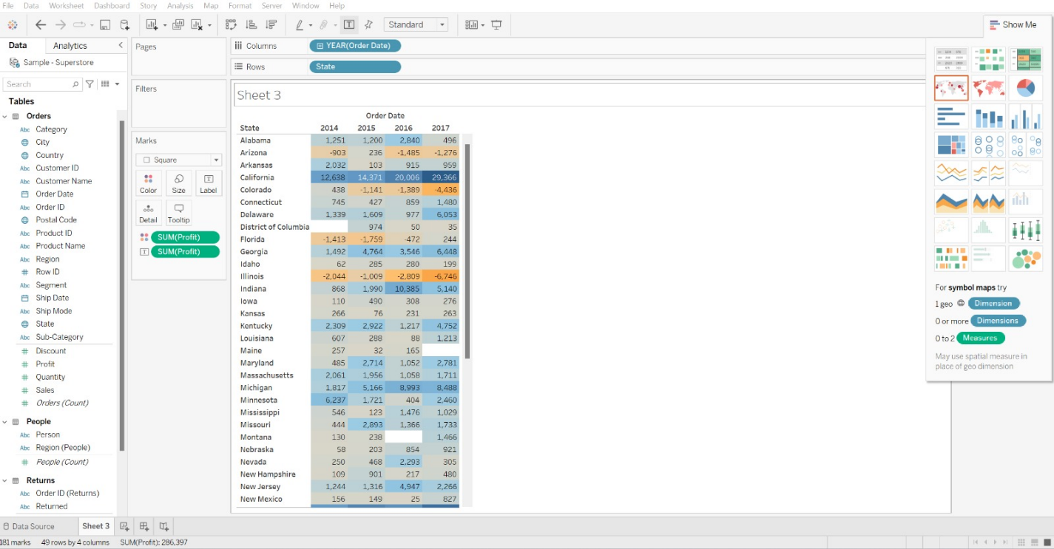

1. Which customer is having maximum returns of sales in the year 2011? -Global Superstore

